POWER QUERY – fxSelectTableColumns()

/* fxSelectTableColumns()

A function to select columns from a table using a function instead of a hard coded list.
The function will be used by List.Select() to return a list to feed Table.SelectColunns(),
which allows for dynamic column selection. Most of the interesting code can be found in the
test suite, as this function hands off the logic to the column_selector function.

Parameters
input_table - a table object
column_selector - a logical function taking a single text parameter,
i.e. a column name that indicates if the column name starts with
the substring in the function's definition, contains a string
representing a single month’s abbreviation, or is a list of month
abbreviations

*/

(input_table as table, column_selector as function) as table =>
let
table_column_names = Table.ColumnNames(input_table),
selected_table_columns = Table.SelectColumns(input_table, List.Select(table_column_names, each column_selector(_)))
in
selected_table_columns

Testing Suite

/* Test fxSelectableColumns()

Try creating functions that returns a valid list of column names for a given table, e.g.
TestTable_1.

Original column headers for TestTable_1:

Product | Color | Category | 31-Jan-22 | 28-Feb-22 | 31-Mar-22 | 30-Apr-22 | 31-May-22 | 30-Jun-22

For the last couple of test cases, I manually added end-of-month date columns to the table
*/

let
//Case #1 - return a single column table [WORKED AS EXPECTED]

my_func = (column_name as text) =>
let
Source = column_name = {"Product"}
in
Source

fxSelectTableColumns(TestTable_1, my_func)

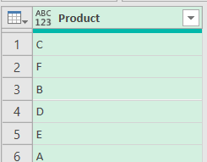

/*Case #2 - return table whose column names beginning with "31"
Got an error when I tried to assign a return type to the anonymous function, e.g. () as list =>
my_func(), as defined here, isn't selecting columns; it's returning a list of columns.
Want a function to act as a SELECTOR that the calling function will use to determine
which columns to select. As currently defined, my_func() has knowledge of the table and its
column names, which does not align with the objective of creating a function that is
agnostic. [DID NOT WORK AS EXPECTED]
*/

my_func = () =>
let
Source = List.Select(Table.ColumnNames(TestTable_1), each
Text.StartsWith(_, "31"))
in
Source

fxSelectTableColumns(TestTable_1, my_func)

/*Case #3 - want calling function to supply the table instead of hard coding table reference in the function we're passing to the calling function.

Can I use the "_" place holder here and then the calling function can supply the actual table? That would be a huge improvement, since the function would now be "agnostic" in re the table it is applied to. NOPE!

At least for this case, in which the calling function is selecting table columns based on the output of my_func(), the function signature for my_func() is (column_name as text), since the calling function will supply a list of column names from the table on which it is invoked. The function being passed to the calling function doesn't have to know the name of the table in advance, as was the case in the previous test. [WORKED AS EXPECTED]

This time, assigning a return type to the function is OK.
*/

my_func = (column_name as text) as logical =>
let
Source = Text.StartsWith(column_name, "31")
in
Source

fxSelectTableColumns(TestTable_1, my_func)

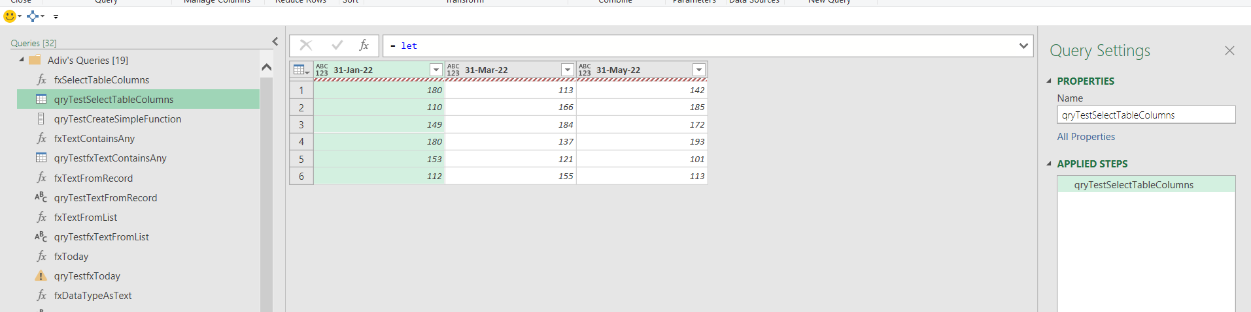

/*Case #4 - a true test of passing different functions with the same signature to the calling function. Here, we use a random number between 28 and 31. Since no column names in TestTable_1 begin with "29", a "column" is returned with just row numbers and no content. However, this is expected behavior and future proofs the function, since if a last-day-of-month column beginning with 29 is ever added to TestTable_1, it will be picked up by my_func_29(). [WORKED AS EXPECTED]

*/

bottom_date_num = 28,
top_date_num = 32, //Use 32 because no random number => 31 will ever be generated if top_date_num is 31
date_nums = {bottom_date_num..top_date_num},
random_date_num = Number.IntegerDivide(Number.RandomBetween(bottom_date_num, top_date_num), 1),
my_func_28 = (column_name as text) =>
let
Source = Text.StartsWith(column_name, "28")
in
Source,

my_func_29 = (column_name as text) =>
let
Source = Text.StartsWith(column_name, "29")
in
Source,

my_func_30 = (column_name as text) =>
let
Source = Text.StartsWith(column_name, "30")
in
Source,

my_func_31 = (column_name as text) =>
let
Source = Text.StartsWith(column_name, "31")
in
Source,

//The function to be passed to the calling function is determined by the position of
//the some_random_num in date_numns, e.g. if 30 is generated, my_func_30() is selected because
//the index of 30 in date_nums is 2, and the index of my_func_30 in func_list is also 2.
func_list = {
my_func_28,
my_func_29,
my_func_30,
my_func_31
},
random_date_num_index = List.PositionOf(date_nums, random_date_num),
passed_function = func_list{random_date_num_index}

The following images are the output of fxSelectTableColumns() when invoked repeatedly, since a random number between 28 and 31 is generated each time.



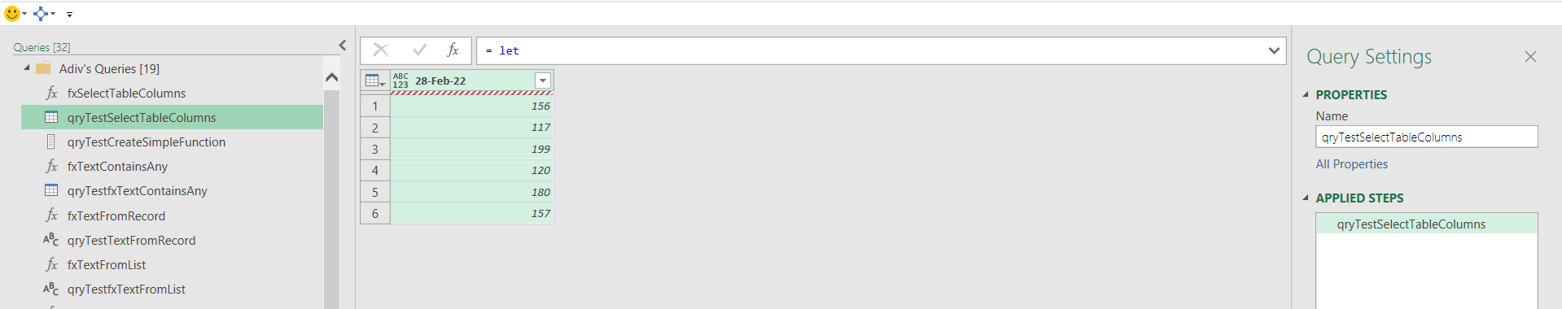

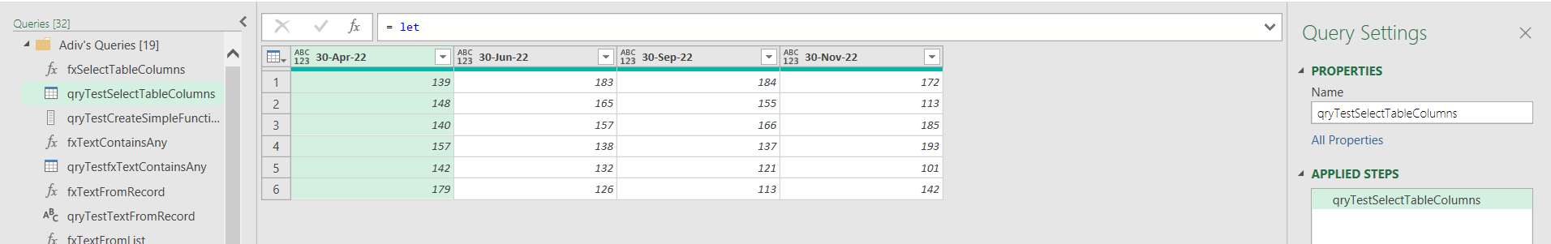

In the following image, the result is an empty list, because the random number generated was 29, and no column names in the table begin with “29”.
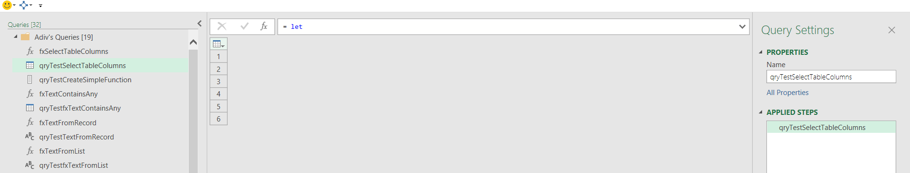

/*Case #5 - Inspired by Microsoft CoPilot, I will now try to create a function factory to dynamically compose the column selector function, which, if I can do this, will eliminate the need for so many essentially identical column selector functions. I won't need a list of discrete functions to index into anymore. The function factory will compose the "predicate" function dynamically, based on the random_date_num as its parameter.
This is very interesting, challenging, elegant, and FUN! [WORKED AS EXPECTED]
*/
bottom_date_num = 28,
top_date_num = 32, //Use 32 because no random number => 31 will ever be generated if
top_date_num is 31
date_nums = {bottom_date_num..top_date_num},
random_date_num = Number.IntegerDivide(Number.RandomBetween(bottom_date_num, top_date_num), 1),
func_factory = (date_num as number) as function =>
let
my_func = (column_name) as logical =>
let
Source = Text.StartsWith(column_name, Text.From(date_num))
in
Source
in
my_func,
passed_function = func_factory(random_date_num)

SAME RESULTS AS IN CASE #4

/*Case #6 - design function factory to return a semantically different inner function depending on the datatype of the parameter passed to the outer function. After I wrote and tested the code. CoPilot said that "Case #6 demonstrates type‑directed structural polymorphism via a closure factory." OK, I'll accept that, because it sounds sophisticated although I haven't a clue as to what it actually means. [WORKED AS EXPECTED]

bottom_date_num = 28,
top_date_num = 32, //Use 32 because no random number => 31 will ever be generated if top_date_num is 31
date_nums = {bottom_date_num..top_date_num},
random_date_num = Number.IntegerDivide(Number.RandomBetween(bottom_date_num, top_date_num), 1),
func_factory = (criteria as any) as function => //now accepting a single number or a text value or a list
let
my_func = (column_name) as logical =>
let
set_func_type =
if criteria is number then //original version of predicate function
let
Source = Text.StartsWith(column_name, Text.From(criteria))
in
Source
else
if criteria is text then //Use to select column by month name, e.g. "Apr" or "Dec"
let
Source = Text.Contains(column_name, criteria)
in
Source
else
if criteria is list then //Use to select months of a quarter, e.g. "Jan", "Feb", "March"
let
Source = fxTextContainsAny(column_name, criteria)[FoundAny]
in
Source
else
error Error.Record("Invalid input", "func_factory accepts number, text, or list only")
in
set_func_type

in
my_func,
criteria_list = {30, "Aug", {"Jan", "Feb", "Mar"}, {"Dec", "Jan", "Oct", "May"}},
passed_function = func_factory(criteria_list{0})
in

(fxSelectTableColumns(TestTable_1, passed_function))



passed_function = func_factory(criteria_list{1})
in

(fxSelectTableColumns(TestTable_1, passed_function))

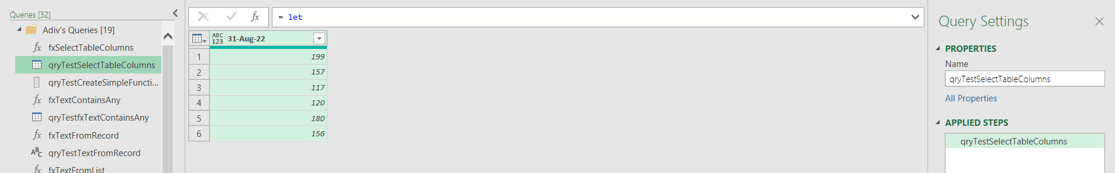

passed_function = func_factory(criteria_list{2})
in

(fxSelectTableColumns(TestTable_1, passed_function))

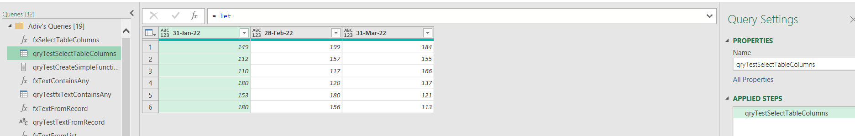

passed_function = func_factory(criteria_list{3})
in

(fxSelectTableColumns(TestTable_1, passed_function))

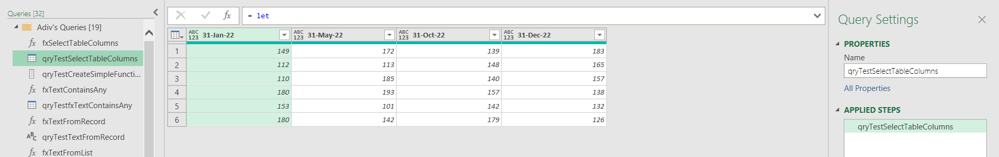

Note that the order of columns returned is always the original order and does not reflect the order in the predicate, or factory function.

